The Water Cycle
Key Revision Facts: GCSE Science

Water is constantly being recycled, the water recycling process is called Water Cycle.
There are 4 main stages in the water cycle: evaporation, condensation, precipitation and collection.
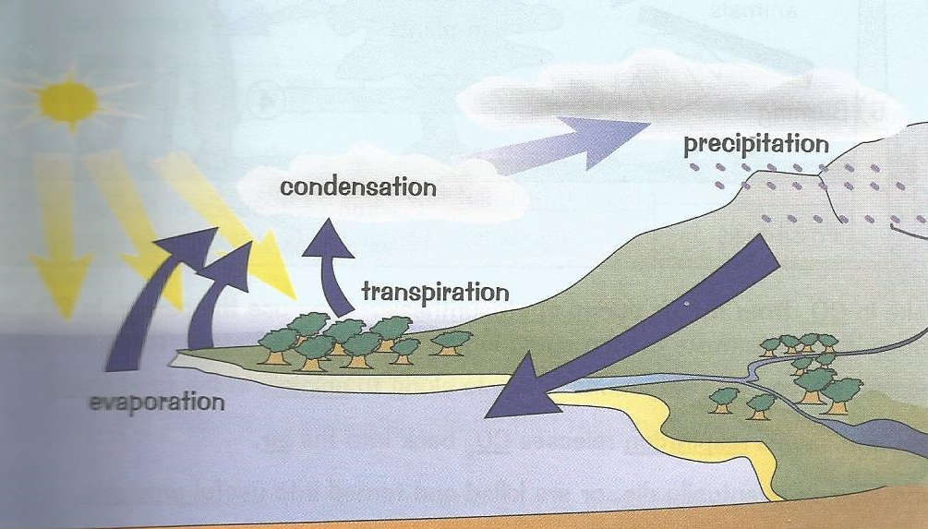

Evaporation – Energy from the sun makes water evaporate from the land and sea.
Transpiration - Energy from the sun makes water evaporate from from plants.
Condensation - When the air cools down, the water vapour condenses back into water droplets. These water droplets collect together and form clouds.
Precipitation - The water droplets in clouds attract other water droplets to them and they grow bigger. When they get too big and heavy they fall to ground as rain. If the air is cold enough the droplets remain frozen and fall as snow or hail.
Collection - When the water falls to Earth it collects as streams, rivers or lakes. When it falls on land in can filter in to the Earth and become groundwater or it can flow over the land as run off to meet sea and oceans.

Download
More Key Fact Revision sheets can be downloaded from
www.andrew-seaford.co.uk/revision

Version information
Date | Arthur | Comment
17-Jan-2021 | Andrew Seaford | Initial release.

